What is AWS Secrets Manager?
AWS Secrets Manager is a service used to securely store, manage, and retrieve sensitive information called:
Secrets
Examples:
- Database passwords
- API keys
- SSH keys
- Tokens
- Application credentials
If you store passwords directly inside:
- Code
- Scripts
- GitHub
it becomes a huge security risk.
Instead, applications securely fetch credentials from:
AWS Secrets Manager
For example:
Application needs:
- MySQL database password
Instead of hardcoding:
password = "MyPassword123"
Application fetches password securely from:
AWS Secrets Manager.

Let’s do a hands-on to understanding this better
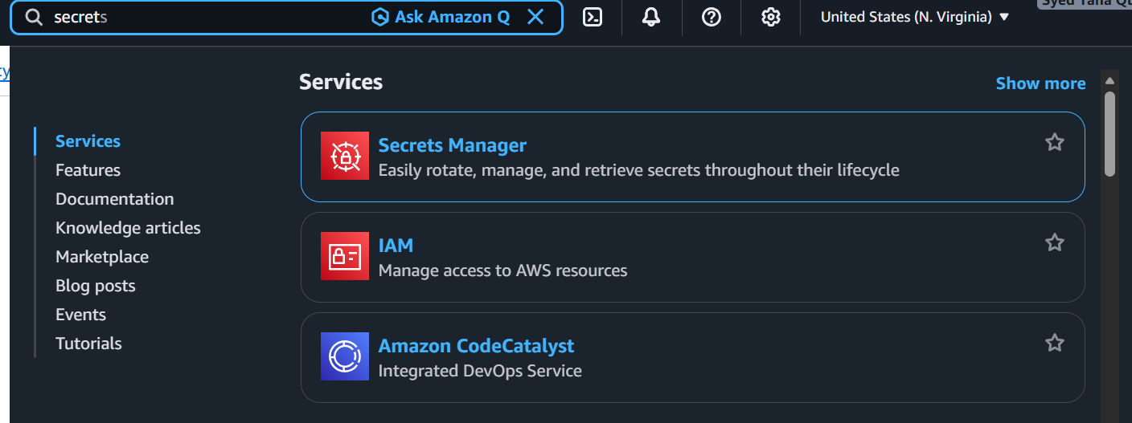
Search for secrets manager and select
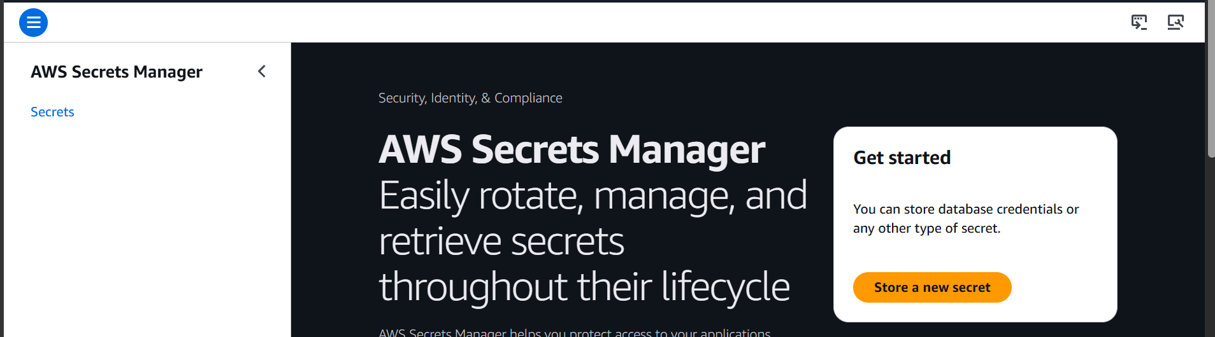

Now click on store a new secret
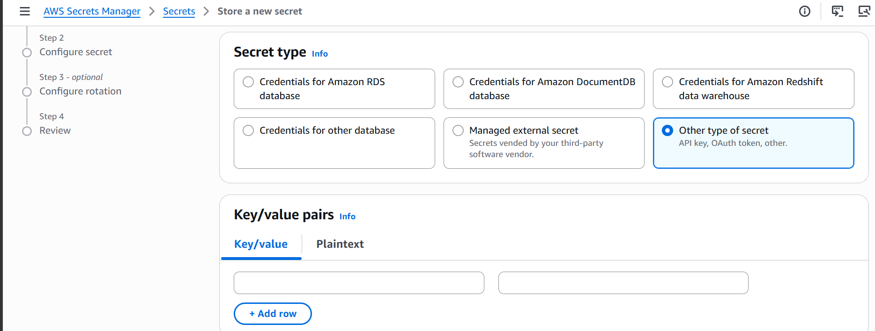
Select other type of secret
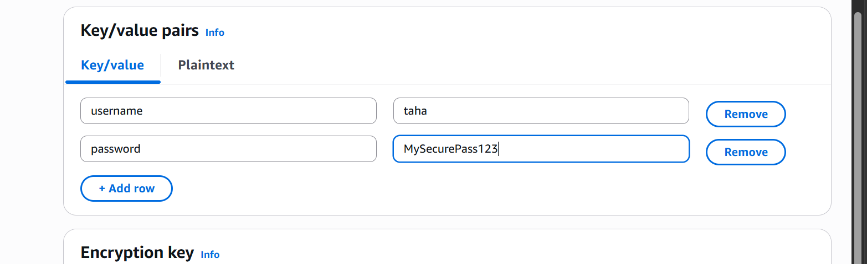
Create a key value pair for username and password
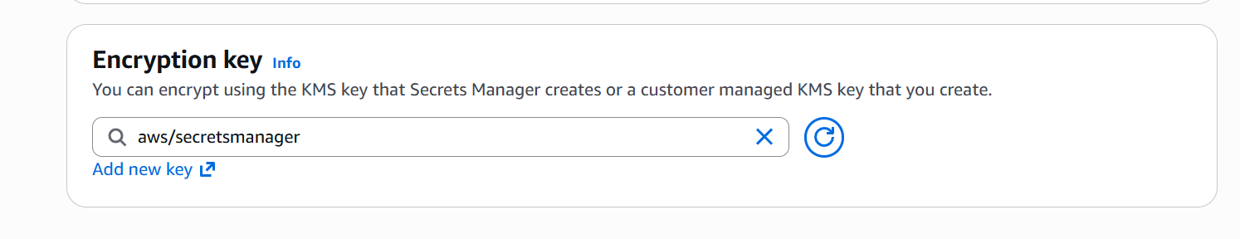
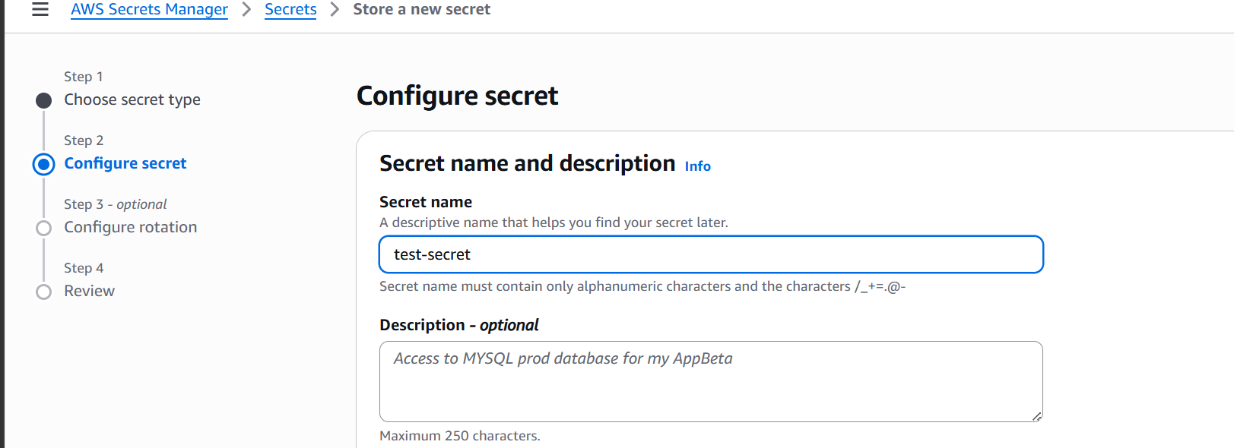

Give it a name
Now store the secret

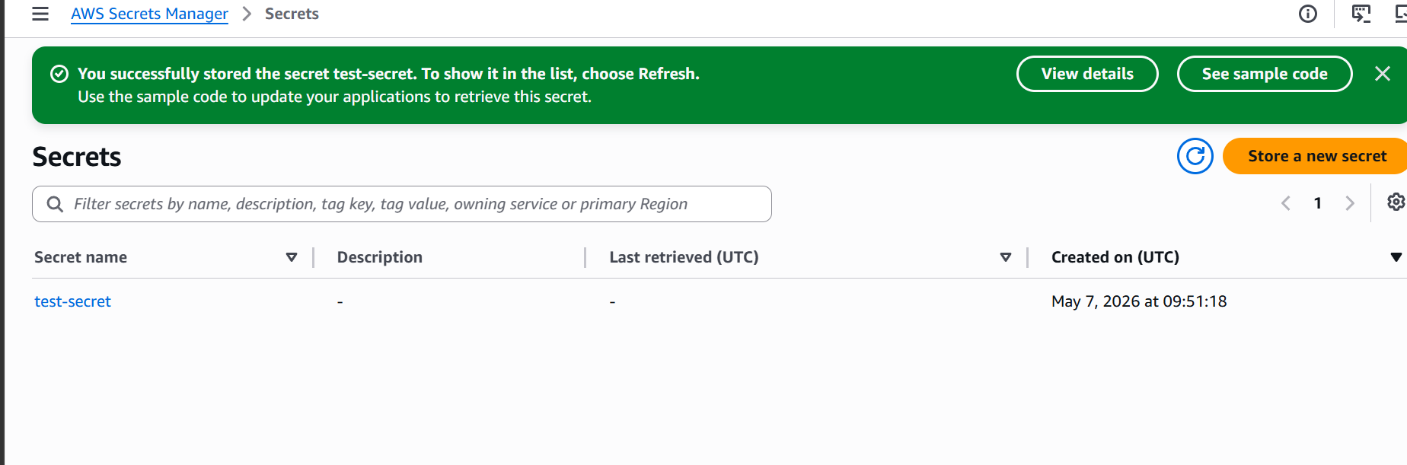
Secret is now stored
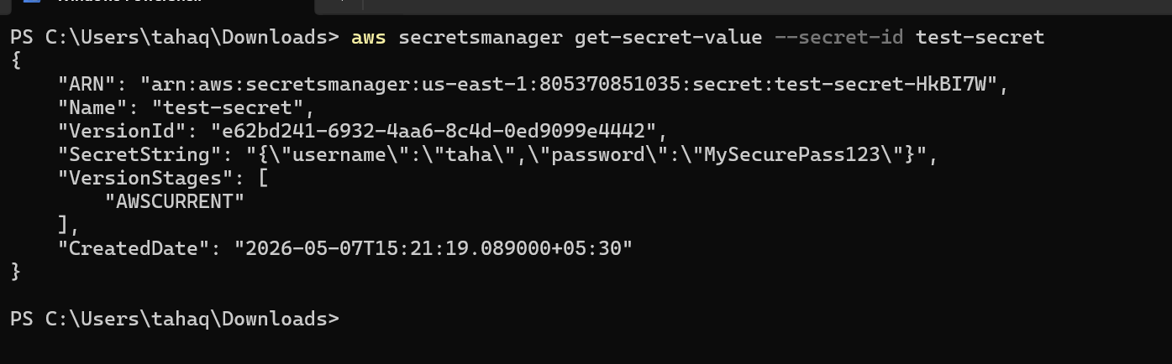
We are able to download it from the cli as well

